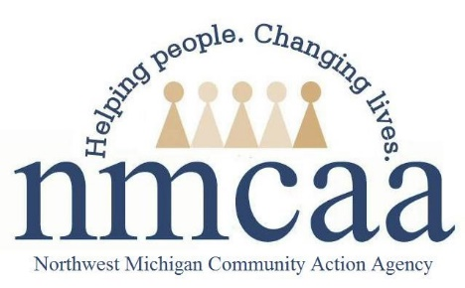

Recruitment and Acceptance Guidance for Child and Family Programs
HSPPS 1302.13
- The recruitment process is designed to actively inform all families with eligible children within the recruitment area of the availability of program services and assist them in applying for admission to that program.
  - Recruitment materials will list all EHS options available in the area
  - Recruitment posters for HS and EHS will be made available to all staff
  - Recruitment posters containing information about EHS and HS will be available when there is only space for one poster (ex. NMCAA website page)
- Recruitment efforts will include but are not limited to:
  - Attending community events
  - Presenting to community agencies
  - Parent-led recruitment
  - Facebook
  - Web pages
- Power Points containing information about all programming will be available to use at community agency presentations
- Elevator speeches will be provided to support recruiting for all programming.
- All recruitment materials must be approved by a Manager before use.

Pre-Application Guidance
- The program that the family has chosen will contact them.
  - If there is no program in that county that the family has chosen, the program in that area can reach out to the family to share the programs available in their area
- The program that plans to contact the family will highlight in their designated color
  - Yellow-HS/GSRP programs
  - Pink - TCAPS
  - Blue – EHS Home Based
  - Orange – HS Collaborative Centers/EHS Child Care Partners/EHS Center Based
- Once the application is completed, the information will be deleted from the pre-application chart

Interest Form Guidance
- EHS R & H have individual links for their area, they will send family contact information to the recruitment personnel from the program chosen by the family.
- A Universal link for all 10 counties will be used when advertising goes out to all of our service area, such as our website
  - EHS PSC will send family contact information to the recruitment personnel from the program chosen by the family.

Acceptance when more than one NMCAA program is available in the area
- Ensure there are no eligible children on your wait list
- If there are no eligible children, review the other waitlist(s) in your area with notes to see if the program you are recruiting for was listed as a second or third preference, or if there is other relevant information.
- If there are potential children:
  - First, contact the Enrollment Specialist from that waitlist to discuss possibilities for that family, get updated information regarding the family and their status with the program.
    - EHS Home Based – Program Service Coordinator
    - EHS Collaborative Centers – Collaborative Center Services Coordinator
    - EHS Center Based – Site Coordinator
    - HS/GSRP – ERSEA Manager

6/20 HS/EHS/MISC/Home Visit Guidance

