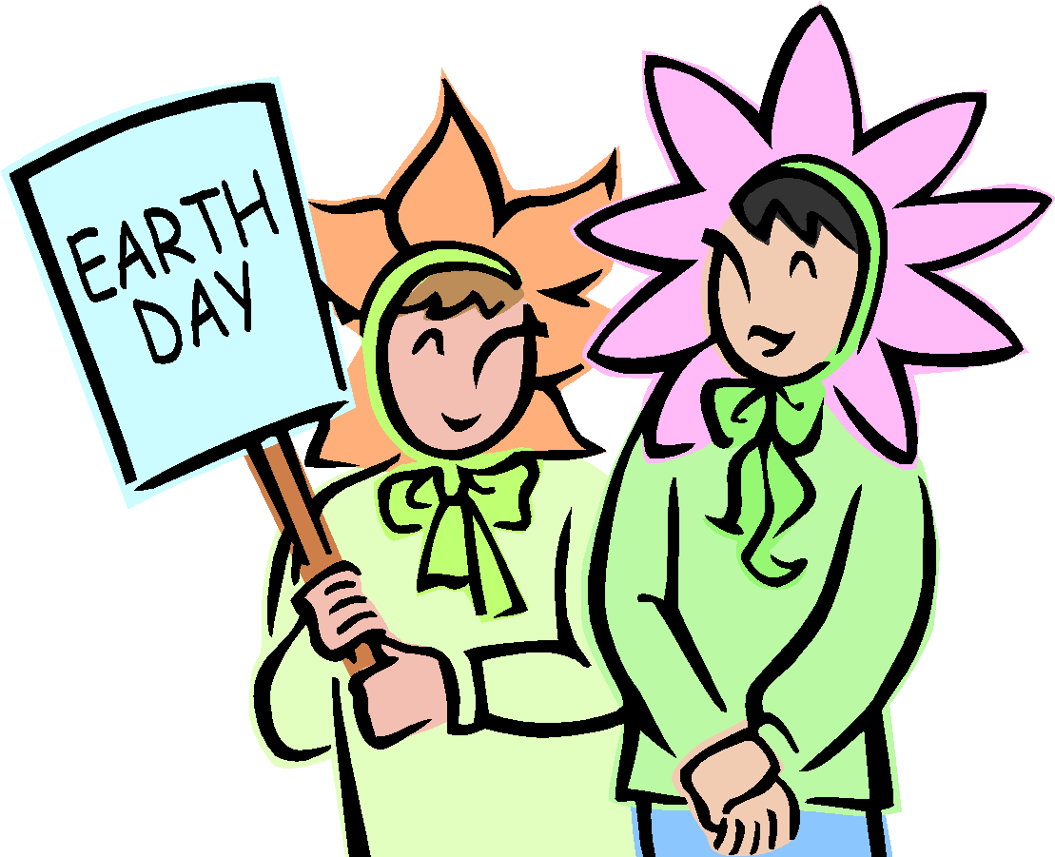 August Home Activity Calendar
Sun | Mon | Tue | Wed | Thu | Fri | Sat
Early Head Start Center;_________________________________________

Child’s Name:_____________________________________________
Sand art- write/draw in the sand.  Obj. 7a, 8, 9a | Blow bubbles with various items around the house.  Obj. 2a, 6, 11a-e | While outside practice kicking a ball. Make it as easy as possible at first.  Obj. 4, 5, 6 | Play “Monkey See, Monkey Do.” Take turns mirroring each other’s simple actions.  Obj. 1a & b, 2a | LIsten to soothing music as you stretch with your child. Keep it fun.  Obj. 2a, 4, 6 | Have your child turn the book pages as you read or describe the pictures of a book.  Obj. 1a&b, 17b, 18a | Watch airplanes as they pass overhead. Wave bye-bye to the plane.  Obj. 30, 31, 32
Puddle play- Give your child plastic animals, boats and dolls and watch as your child rules his watery kingdom.  Obj. 24, 26, 27 | Encourage your child to wave good-bye. It practices motor and social skills.  Obj. 1b, 2a-d,3a | Collect leaves from your yard or a park. Look at them together and talk about characteristics.  Obj. 9c, 12a&b, 13&27 | Sink or floats- Let your child experiment with different items to see what floats and what sinks. Sort them by what happens in the water.  Obj. 13, 24, 26 | Invite your child to “finger paint” on graham crackers with yogurt or pudding. When he’s done, he can eat his artwork.  Obj. 6, 33 | Take a little down time and snuggle with your child under a cozy blanket; read a story, talk, or just watch the tree branches swaying overhead.  Obj. 25, 27, 32 | Seek and find-draw your child’s attention to a small toy then slowly slip it under the towel while she’s watching. See if she uncovers the toy.  Obj. 5, 12a
Visit the library and check out some storybooks. Rotating books will help keep him interested.  Obj. 15c, 16b, 17a & b | Provide your child with a variety of boxes to open and close. Hide toys inside to encourage exploration.  Obj. 4, 5, 6 | Build towers- using old boxes (cereal, pasta, oatmeal, etc.) Count the number of boxes, compare tower height and child's height.  Obj. 6, 20b, 22 | Take a sensory walk with your child. Enjoy the sounds, the smell, colors and shapes of items found on your walk.  Obj. 8a, 9d | Play clapping and hand games such as peek-a-boo and pat-a-cake.  Obj. 1a, 3a, 10b | The next time your child is cranky, pull him into your lap for a hug. Your support will help him face the world again.  Obj. 1a-c, 2a & b | Fill a dishpan with water and throw in some small citrus fruit. Add a plastic cup or strainer with a handle. Let him imagine if these are fish, boats or walnut people.  Obj. 6a, 14a&b
Offer an empty wide-mouth container (Oatmeal container) to your child along with some blocks. She’ll have a great time dropping them in and taking them out.  Obj. 6, 7a, | Dig for treasure- place a few toys in a sensory bucket for them to dig and find.  Obj. 7a, 11d | Write or draw with your child.  Obj. 16a, 17b, 19a | Mirror Play- Ask your child “Who’s that in the mirror?” or “Where is that baby’s nose?” See if he tries to touch his nose or the nose in the mirror.  Obj. 11e, 29 | Mix some music that you like into your child’s music. Involve your child by dancing with her and clapping out rhythms.  Obj. 11a- e | Play with playdough- roll, squeeze, stretch or cut with cookie cutters.  Obj. 7a, 11a-e, 16a | Sing a song on a rainy day.  Obj. 8a, 34, 36

Educational Home Activity GOLD Objectives

Social Emotional Cognitive Mathematics
1. Regulates own emotional and behaviors 11. Demonstrates positive approaches to learning 20. Uses number concepts & operations
a. Manages feelings a. Attends and engages a. Counts
b. Follows limits and expectations b. Persists b. Quantifies
c. Takes care of own needs appropriately c. Solves problems c. Connects numerals with their quantities
2. Establishes & sustains positive relationships d. Shows curiosity and motivation 21. Explores & describes spatial
a. Forms relationships with adults e. Shows flexibility & inventiveness in thinking relationships & shapes
b. Responds to emotional cues 12. Remembers and connects experiences a. Understands spatial relationships
c. Interacts with peers a. Recognizes and recalls b. Understands shapes
d. Makes friends b. Makes connections 22. Compares and measures
3. Participates cooperatively and constructively 13. Uses classification skills 23. Demonstrates knowledge of patterns
In group situations 14. Uses symbols and images to represent something not present
a. Balances needs and rights of self and others a. Thinks symbolically
b. Solves social problems b. Engages in sociodramatic play

Physical Literacy Science & Technology
4. Demonstrates traveling skills 15. Demonstrates phonological awareness 24. Uses scientific inquiry skills
5. Demonstrates balancing skills a. Notices and discriminates rhymes 25. Demonstrates knowledge of the
6. Demonstrates gross motor manipulative skills b. Notices and discriminates alliteration characteristics of living things
7. Demonstrates fine motor strength & coordination c. Notices and discriminates smaller and smaller 26. Demonstrates knowledge of the
a. Uses fingers and hands units of sounds physical properties of objects & materials
b. Uses writing and drawing tools 16. Demonstrates knowledge of the alphabet 27. Demonstrates knowledge of Earth’s
a. Identifies and names letters environment
Language b. Uses letter-sound knowledge 28. Uses tools and other technology to
8. Listens to and understand increasingly 17. Demonstrates knowledge of print and its uses perform tasks
Complex language a. Uses and appreciates books
a. Comprehends language b. Uses print concepts Social Studies
b. Follows directions 18. Comprehends and responds to books and other texts 29. Demonstrates knowledge about self
9. Uses language to express thoughts and needs a. Interacts during read alouds and book conversations 30. Shows basic understanding of people
a. Uses an expanding expressive vocabulary b. Uses emergent reading skills 31. Explores changes related to people
b. Speaks clearly c. Retells stories 32. Demonstrates geographic knowledge
c. Uses conventional grammar 19. Demonstrates emergent writing skills
d. Tells about another time or place a. Writes name The Arts
10. Uses appropriate conversational & other communication skills b. Writes to convey meaning 33. Explores the visual arts
a. Engages in conversations 34. Explores musical concepts
b. Uses social rules of language 35. Explores dance & movement concepts
36. Explores drama through action & language
Please record the total amount of time spent doing the above activities:_____________

Parent Signature:_________________________ Date:____________
*By signing I am verifying I completed the stated activities with my child for the amount of time indicated.

Teacher Signature:________________________ Date:____________

