Child Plus: Entering ASQ and DECA Results
- In the “Services” tab (1 below) select the name of the participant you would like to enter ASQ or DECA information for.
- Click on “Health” (2 below), then click on “Events” (3 below).
- Select “Add Event” (4 below), then choose “ASQ” or “DECA.”
1

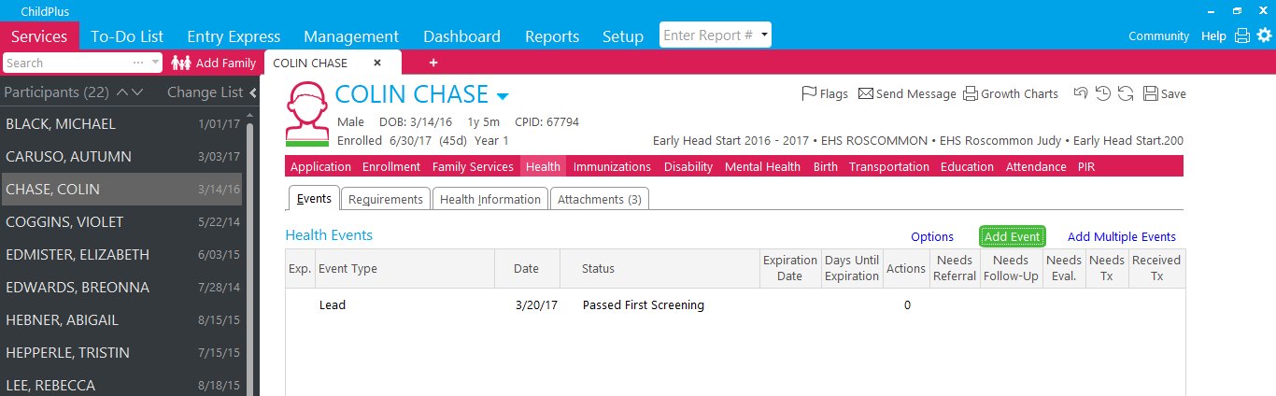
4
2
3

Passed ASQ or DECA
- Enter the “Event Date” as the date that the ASQ or DECA was conducted. An expiration date will automatically populate.
- Under “Status,” select “Passed First Screening.” For “Agency Worker,” enter your name.
- Under “Results,” type ASQ and the mo of the ASQ being conducted (ex// ASQ 18 months). In the “Results” section for a DECA, type the overall TPF score as Strength, Typical, or Need (ex// DECA= Typical)
- Select “Head Start Staff” under “Provider Type” and “Head Start” for “Funding.”
- All other fields can remain blank (See below for an example of completed screen).
- Click “Save.”

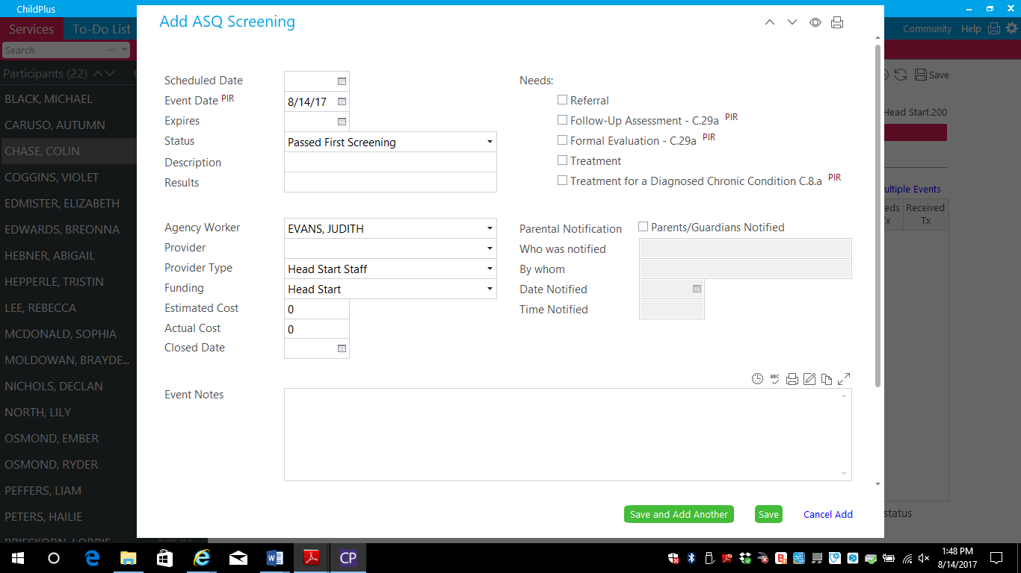

Child Plus: Entering ASQ and DECA Results
Needs Re-Screen or Referral
- Enter the “Event Date” as the date that the ASQ was conducted.
- You will not enter an “Expires” date, although it is okay if one automatically populates.
- Under “Status,” indicate “Needs Re-Screening, Failed 1st” or “Failed 1st Screening, Needs Referral.”
- In “Results,” type in a description of the area of concern.
- For “Agency Worker,” enter your name.
- Select “Head Start Staff” under “Provider Type” and “Head Start” for “Funding.”
- Click the time stamp icon by “Event Notes” and enter in further pertinent details, such as the date a rescreen will occur.
- All other fields can remain blank (See below for an example of completed screen).
- Click “Save.”

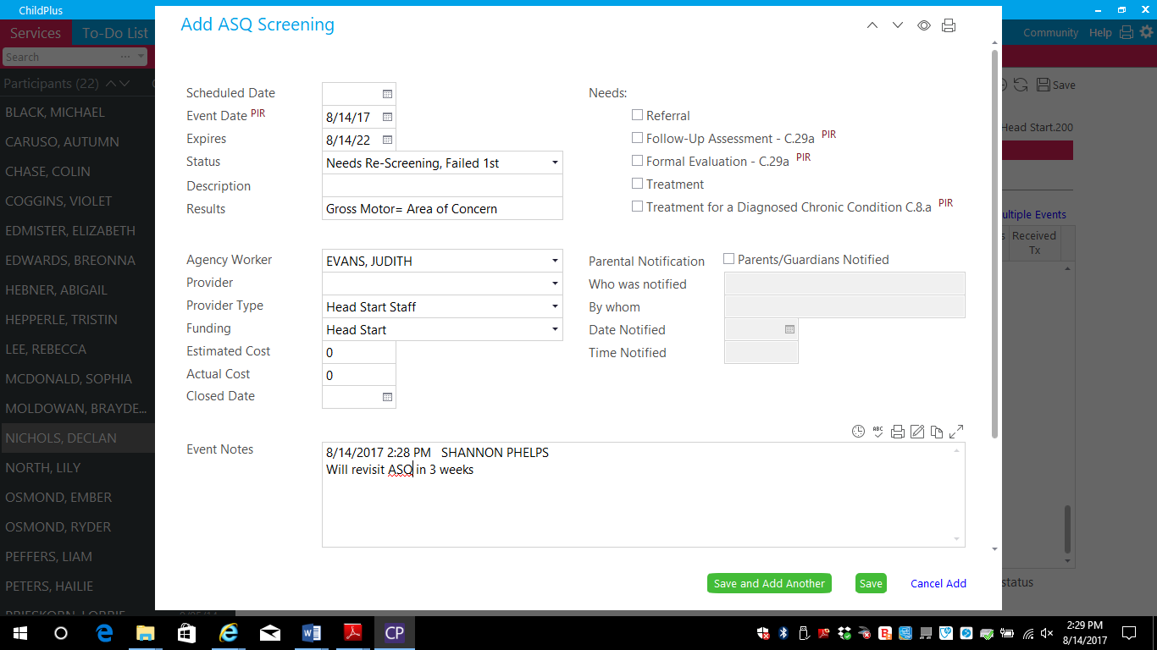

- Note for DECA rescreens and referrals: If there are no areas of concern revisit in one year, one area of concern revisit in 3-6 months, 2-3 areas of concern revisit in 6-8 weeks. Contact the Mental Health Manager if concerns remain and/or are serious in nature.

Child Plus: Entering ASQ and DECA Results
Adding Follow-up Information for Needs Re-Screen or Failed 1st Screening
- Locate and select your initial ASQ or DECA entry under the “Health” and “Events” tabs (highlighted below).
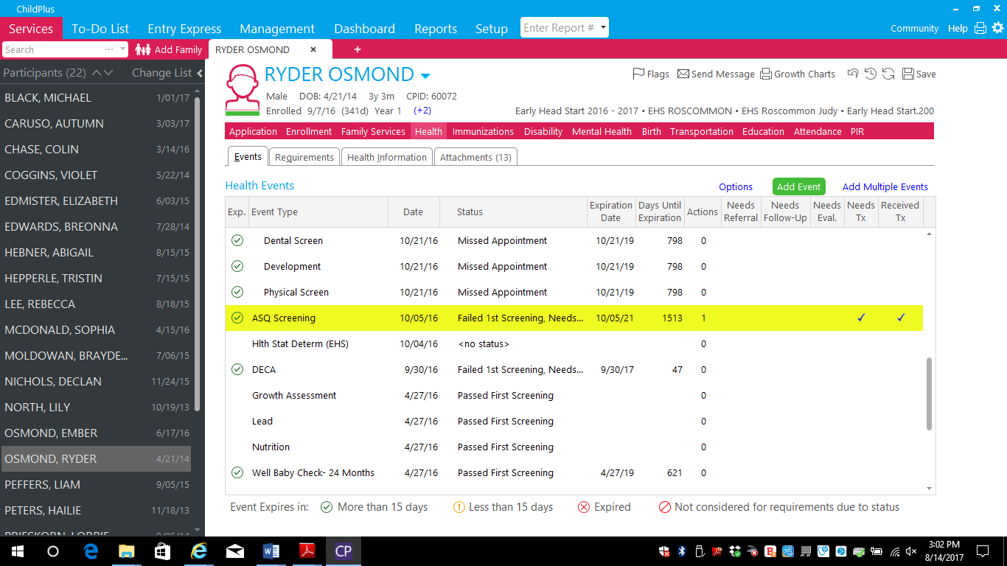

- Using the scroll bar, (1 below) locate and select “Add Action” (2 below).

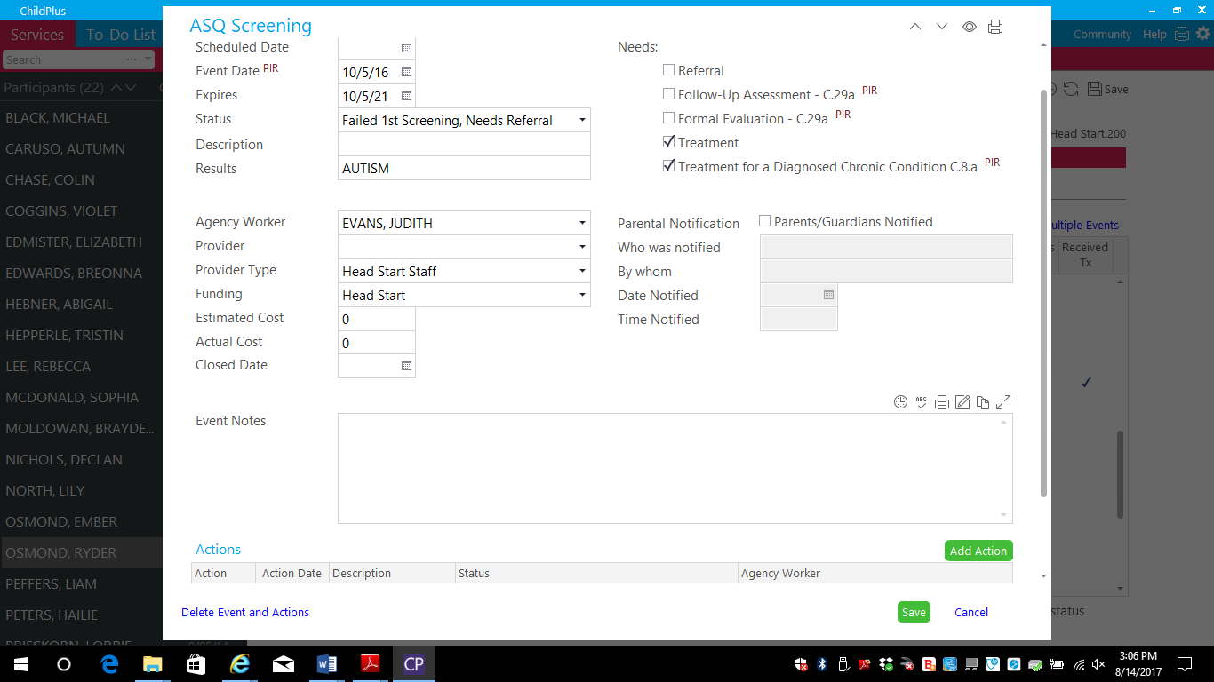
1
2

Child Plus: Entering ASQ and DECA Results
Adding Follow-up Information for Needs Re-Screen or Failed 1st Screening
- Under “Action Type,” select “Follow-Up” or “Treatment.” You will not use any of the other options available.
- Enter the date the action occurred under “Action Date.”
- Under Status, select the most relevant option. This will most likely be one of the following: “Pass,” “Referred 1st Screening,” “Treatment Complete,” or “Treatment Current/Up to date.”
- Date stamp the “Action Notes” section and type a description of the new status.
- Click “Save.”
- Two examples of how this may look can be can be seen below.

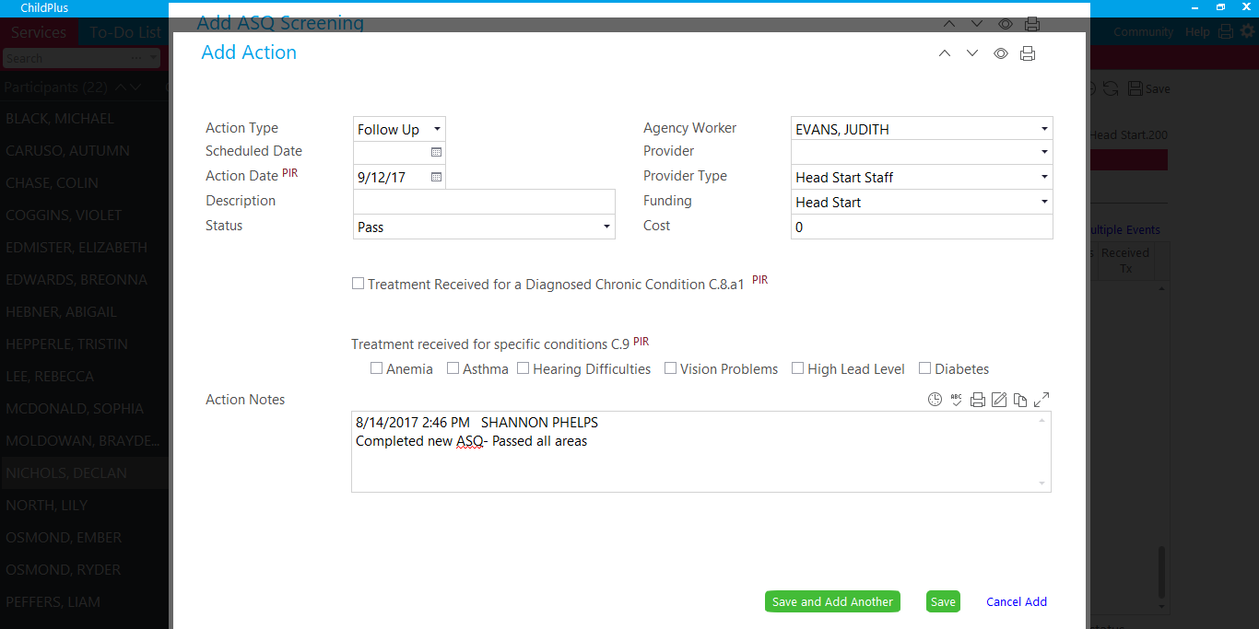

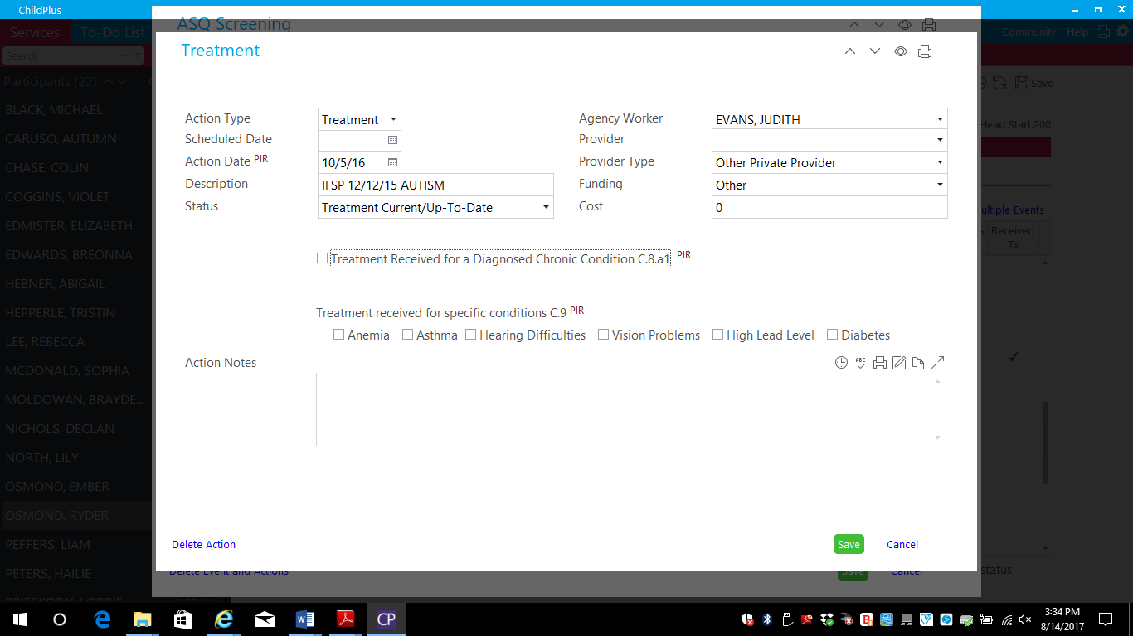

*Report 3065 in ChildPlus will show all outstanding health requirements, including ASQs and DECAs.

