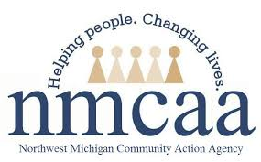
NMCAA Early Childhood Nutrition Plan
The purpose of our nutrition plan is to teach children, families, and staff the importance of nutritious eating through education, experience and by example.
Our nutrition plan is important to children, families, and staff as it provides a framework for supporting healthy food choices as well as nutritional resources for families and staff. Additionally, our plan encompasses regular communication regarding nutrition topics, which is so important in supporting the family-to-school connection.
The tools and resources we use in our program include the following: We currently participate with the Child and Adult Care Food Program and are in good standing. We follow CACFP guidelines, Head Start Program Performance Standards, Licensing and GSRP regulations, and use a nutrition analyst. We take advantage of grants and programs such as MSU Extension. We collect and evaluate planned monthly menus and served monthly menus using our nutrition analyst. We provide feedback to classrooms and vendors based on the nutrition analyst’s findings, as necessary.
We meet the needs of children, families, and staff by providing nutritional family-style meals and snacks to the children and staff, providing foods that are low in fat, sugar and salt, increased servings of fresh fruits and vegetables, adding a meat/meat alternate to breakfast, teaching servings sizes, introducing children and families to different foods, modeling for children and families, and learning about and respecting different cultures through food. We work with families to meet their children’s individual nutritional needs, providing food substitutions when needed. We also hold family engagement activities that include meals and/or snacks that follow our nutrition requirements.
We share our nutrition information with children, families, and staff through our parent handbook, new child cover letter, new staff orientations, activities in the classroom, and yearly staff nutrition trainings. Additionally, all our planned, CACFP-approved menus are posted and accessible to families and staff.

