How Can You Help?
• • •

Here are some examples of ways you can provide In Kind for our program:
- Volunteering in the classroom, which may include:
  - Sharing a meal with your child at school
  - Playing outside with children during our outside time
  - Sharing a hobby or talent with the class (ex: singing, woodworking)
  - Reading stories to children
  - Bringing in “treasures” to share with children (ex: artwork, baseball card collections)
  - Cleaning/fixing/gardening/etc. to keep the center looking great
- Completing extension activities provided by your EHS home visitor and listed on the home visiting lesson plan
- Doing at-home activities to further your child’s development:
  - Classroom Monthly At-Home Activity Calendars
  - Activities that are tied to the Creative Curriculum or Parents as Teachers curriculum to help with your child’s school readiness
- Helping with arrangements and participating in field trips, parent meetings, and family engagement activities
- Attending parent trainings
- Making/preparing materials for the classroom or for your upcoming home visit (ex: cutting out materials for an activity, making play-dough, collecting materials necessary for the home visit activity)
- Travel time and participation in an Open House, IFSP, IEP, IAP, Emergency Care Plans, Transition Meetings, and Parent Teacher Conferences
- Travel/appointment time (appointment time ONLY if private insurance) and mileage for program-required medical/dental appointments
- Travel/mileage only for WIC, Health Dept., and Dental Clinics North
- Time completing an e-DECA outside of a home visit
- Donating materials to be used in the classroom.
- Serving on Policy Council
- Please ask your child’s teacher or home visitor for additional options
Other Ways We Get In-Kind
- Community “celebrities” visiting the classroom (ex: librarian, elementary school principal, firefighter)
- Donated materials from local businesses of food or supplies for classroom or parent activities
- Any volunteer time in the classroom (ex: college students, foster grandparents)
What is In Kind?
NMCAA Head Start

Definition of In Kind

In order to fund your child’s Head Start preschool program and home visiting program, we must receive 20% of our total funding from local donations of time, money, materials, and services. This funding source is called In Kind. This means we need help from parents and the local community to continue to operate our Head Start program. Parent involvement in their child’s education is key to their future success and In Kind is a great way to be involved.

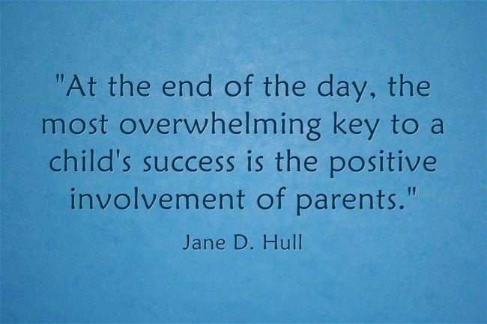

7/22 References: HS 1303.4
P:Head Start/ADMIN/Procedure Manual/In-Kind/What is In-Kind?

