Instructions for how to access Intentional Teaching Experiences.
Step 1: Login to My Teaching Strategies

Step 2: Select the “Teach” icon at the top of the screen.
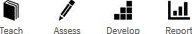

Step 3: Head Start Teachers select “Week” from the menu at the top left corner of the screen.
OR Early Head Start Teachers select “Weekly Experiences” from the menu at the top left corner of the screen.

Step 4: Select from the top of the list of menu option on the left side of the screen.

Step 5: Choose any day of the week and then click “Next” from the upper right side of the calendar.
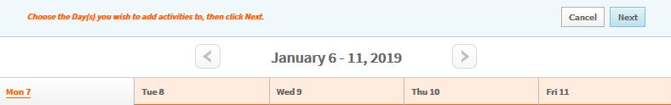

Step 6a: Select “Intentional Teaching Experience”.
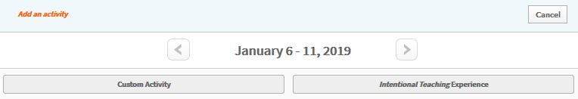

Step 6b: FOR EHS ONLY Select “By Objective/Dimension”.
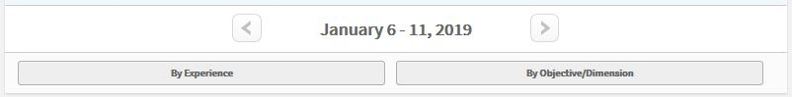

Step 7: This page lists objectives/dimensions for you to choose from. Select an objective/dimension of interest. In this example, Social-Emotional is chosen.
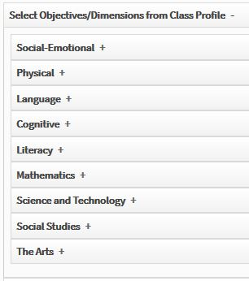

Step 8: This page lists the objectives/dimensions for the selected dimension on the left side of the screen. Across from each objective/dimension is listed the names of each child at the level you previously assessed each child to have attained. The color bands are included to represent where each child is at compared to what is typically expected of children the same age for each objective/dimension.
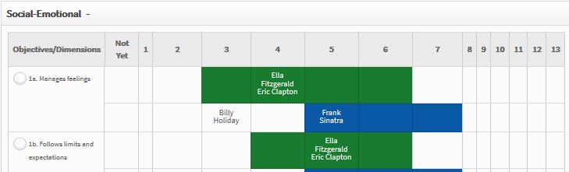
Step 8 Continued: Notice if there is an objective/dimension where any of the names are to the left of the color band. These children have been assessed to be below expectations for what is typically expected for children the same age.
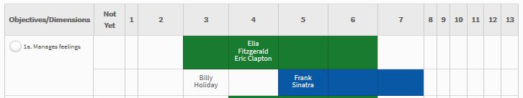
If you see names to the left of the color bands select that objective.
If all children are within or to the right of their color bands for every objective/dimensions. Choose any objective of interest.

Step 9: Select one of the Intentional Teaching experiences to preview.
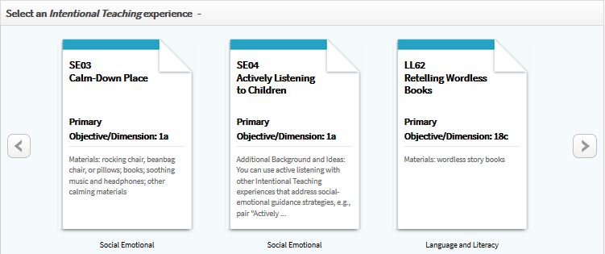

Step 10a: Once you select an experience to preview, you will see instructions to implement the activity.
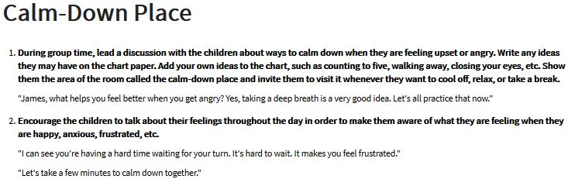
Step 10b: Below the initial instructions you will see a two columns. The left side has the children listed within their assessed color bands. The right side has more instructions modified to match the developmental levels within each color band.
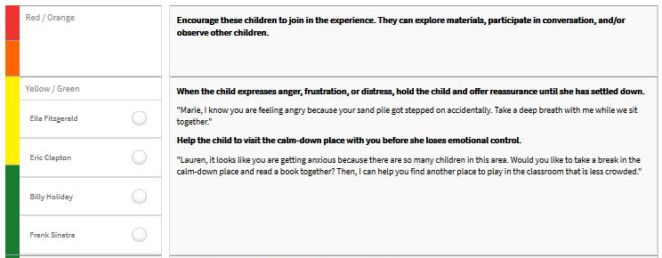

Step 10c: To the far left you will see a menu list. Explore each choice to see all this section has to offer.
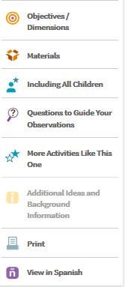

Step 11: Choose print and implement the activity. - OR - Add the previewed activity to your lesson plans in GOLD by select a child or children, then select “Add to Plan”. To preview another, select “Return to Planning”.

