This guidance is for documenting educational contacts and attendance with families enrolled in remote learning. This will include any communication with the families. This will also include ReadyRosie messages and videos, zoom meetings and group meetings. Social Service contacts will be recorded on the SS7 and sent to DMT. Using Entry Express will allow you to input information for multiple families at the same time with the same type of contact and date.
- Select “Entry Express” from the bar at the top of the screen, then select “Log a Communication”.
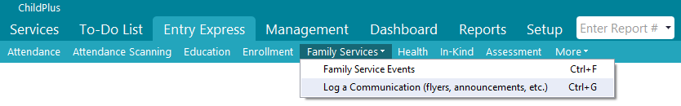
- Next select Program Term, Sites, Classrooms, and Status and Filter by Group (choose Remote Learner) Then select “Find” from the bottom of the screen.

- The next step is to “Select the participants for whom you want to log a communication”. To do this select “Uncheck All” from the bottom of the screen and then reselect the families who received the communication/contact and select “Next Step” at the bottom of the screen.

- Then complete the Action Type, Action Date, Type of Contact, Description, Status, Case Worker, and Action Notes. Example of a description would be: Email from RR, zoom meeting, group meeting, etc. Be sure to date stamp any action notes prior to typing in the notes.

- “Action Completed” for the status will be used when a family has watched a video or opened an email. If a family has not opened either of these by the following Sunday evening, the Status will be “Ongoing” and cannot count as a contact for that week.

Examples:
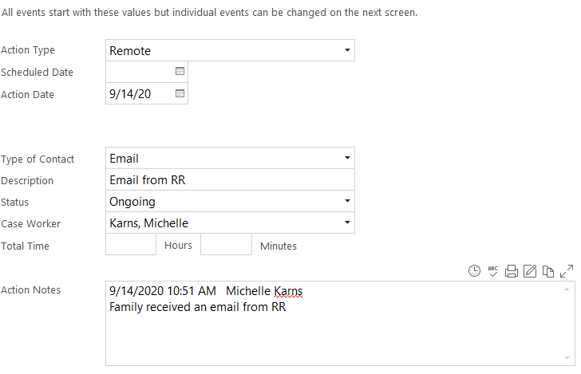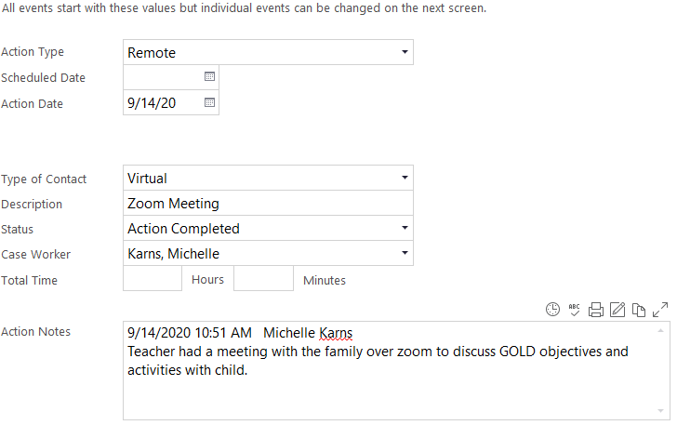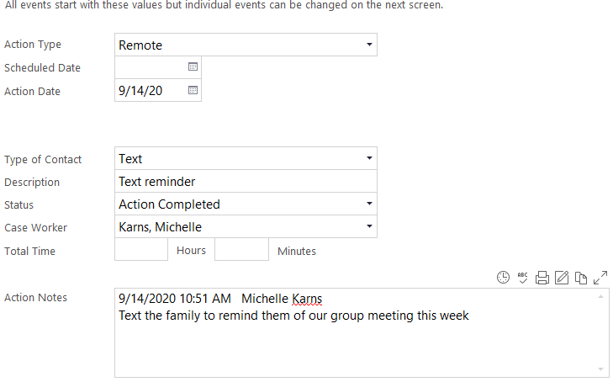
- Finally, select “Create Records”.
- For individual entry go to the child’s Family Service Tab, open the Communication Log, select “Add Action” and complete step 4 above.
10/20

