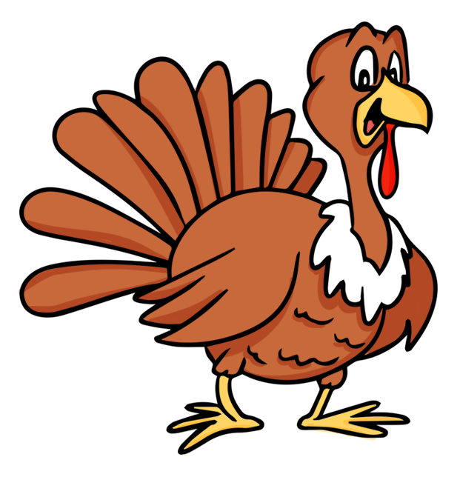 November Home Activity Calendar
Sun | Mon | Tue | Wed | Thu | Fri | Sat
Early Head Start Center:_________________________________________

Child’s Name:_____________________________________________
Sing and gesture the song head shoulder knees and toes.  Obj. 5, 8b, 12b,29 | Visit some animals. If your baby enjoys animals in books, visit a pet store or a petting zoo.  Obj. 8a, 10a, 11d, 25 | Encourage your child to put pipe cleaners or straws into an empty parmesan cheese container.  Obj. 7a,11a-d | Stroke swatches of textured cloth across your baby's body (ex: velvet, fake fur, corduroy, satin).  Obj. 11d, 12b, 26 | Sing a lullaby to your baby.  Obj. 10b, 15a, 34 | Provide scoops and cups for your baby to play with, while in the tub.  Obj. 22, 24, 26 | Help your baby learn about basic colors, by pointing out examples of colors as you talk to him.  Obj.2a, 14a-b, 30
Shape Scavenger Hunt- using a shape puzzle or a picture have your child try to find objects that match that shape in your house.  Obj. 11e, 12b, 21b | Encourage your baby to sing. He may just gurgle or shout but it’s really language he’s learning about.  Obj. 11b, 12b, 15c | Collect photos of each family member, especially those that live out of town. Create a child friendly photo book.  Obj. 9d, 12a, 29, 30 | Draw together. Let your baby draw lines with a crayon or chalk. If she can’t yet, hold her hand gently in yours and guide it on the paper.  Obj. 2a, 7a-b | Blow bubbles for your baby and encourage her to reach out and pop the bubbles. This will increase hand/eye coordination.  Obj. 2a, 5, 6 | Dance with your baby. He may rock or sway but he’ll learn about rhythm and self-expression.  Obj. 2b, 5, 11a, 34, 35 | Let your baby fill his own bag with toys or books, then dump them out again and again. Name the items for him as he fills the bag.  Obj. 7a, 11a, 26
Let your child play with the laundry basket. It makes a perfect fort, playpen, doll crib, or he can throw toys in it and push it around.  Obj. 4, 5, 6, 14a-b | Pull out a muffin pan and let your baby pick up and release objects like balls, toys or crumpled paper into the cups to develop fine motor skills.  Obj. 7a, 11d, 22 | Soothe with heartbeats. Let your baby hear your heartbeat by lying with him on your chest, skin to skin. Or sit with his head on the left side of your chest.  Obj.1a, 2a, 24 | Make a turkey- Color a coffee filter with markers and then spray it with water. Fold in half and place a clothes pin in the middle once it dries. Color the clothes pin brown and add a beak and eyes!  Obj. 7b, 11e, 28 | Cut a hole in the lid or side of a box then show your baby how to stuff toys through the hole. She’ll learn relative sizes and develop fine motor skills.  Obj. 7a, 12a-b, 21a-b | Be silly with the sounds as you read to your child. Encourage your toddler to make the same sounds. When an animal is 'talking,' try to imitate how that may sound.  Obj. 2b, 9a, 18a | While reading stories with your child, have them turn the pages. As you read say I spy the letter.. and point out that letter on the page.  Obj. 2a, 7a,16a,17a
Say to your baby, “how big is baby” and respond “so big” and hold your arms wide. Repeat and help your baby open his arms on his own!  Obj. 2a, 11d, 29 | Place scented ingredients into small containers. (cotton ball soaked in vanilla…) Secure each container,poke holes in the lid, and let your baby sniff the scents.  Obj. 9a, 11a, 24 | Sit on the floor with your baby facing you. Lift him up and while holding him firmly, roll back so he “flies” over your head. This strengthens his back.  Obj. 2a-b, 29, 31 | Teach the concept of size by holding your hands wide then together as you say this simple rhyme with your baby. Big fish, little dish  Big log, little dog.  Obj. 9a, 15a, 22 | Get a big box (from appliance stores) and create a hide out. Cut out windows and a door. Decorate the outside, and tuck blankets and toys inside for a cozy retreat.  Obj., 4, 5 6, 31 | Collect a variety of textures, (sandpaper, fun fur, velcro, etc.) Place the textured items in a tote bag. As you feel each object talk about how they feel.  Obj. 8a, 9a, 24, 26 | Lavish your baby with kisses. Try an Eskimo kiss (rubbing noses), a butterfly kiss (fluttering your eyelashes against his cheek) and an angel kiss (lightly kissing his eyelids with yours).  Obj. 2a-b, 24

Educational Home Activity GOLD Objectives

Social Emotional Cognitive Mathematics
1. Regulates own emotional and behaviors 11. Demonstrates positive approaches to learning 20. Uses number concepts & operations
a. Manages feelings a. Attends and engages a. Counts
b. Follows limits and expectations b. Persists b. Quantifies
c. Takes care of own needs appropriately c. Solves problems c. Connects numerals with their quantities
2. Establishes & sustains positive relationships d. Shows curiosity and motivation 21. Explores & describes spatial
a. Forms relationships with adults e. Shows flexibility & inventiveness in thinking relationships & shapes
b. Responds to emotional cues 12. Remembers and connects experiences a. Understands spatial relationships
c. Interacts with peers a. Recognizes and recalls b. Understands shapes
d. Makes friends b. Makes connections 22. Compares and measures
3. Participates cooperatively and constructively 13. Uses classification skills 23. Demonstrates knowledge of patterns
In group situations 14. Uses symbols and images to represent something not present
a. Balances needs and rights of self and others a. Thinks symbolically
b. Solves social problems b. Engages in sociodramatic play

Physical Literacy Science & Technology
4. Demonstrates traveling skills 15. Demonstrates phonological awareness 24. Uses scientific inquiry skills
5. Demonstrates balancing skills a. Notices and discriminates rhymes 25. Demonstrates knowledge of the
6. Demonstrates gross motor manipulative skills b. Notices and discriminates alliteration characteristics of living things
7. Demonstrates fine motor strength & coordination c. Notices and discriminates smaller and smaller 26. Demonstrates knowledge of the
a. Uses fingers and hands units of sounds physical properties of objects & materials
b. Uses writing and drawing tools 16. Demonstrates knowledge of the alphabet 27. Demonstrates knowledge of Earth’s
a. Identifies and names letters environment
Language b. Uses letter-sound knowledge 28. Uses tools and other technology to
8. Listens to and understand increasingly 17. Demonstrates knowledge of print and its uses perform tasks
Complex language a. Uses and appreciates books
a. Comprehends language b. Uses print concepts Social Studies
b. Follows directions 18. Comprehends and responds to books and other texts 29. Demonstrates knowledge about self
9. Uses language to express thoughts and needs a. Interacts during read alouds and book conversations 30. Shows basic understanding of people
a. Uses an expanding expressive vocabulary b. Uses emergent reading skills 31. Explores changes related to people
b. Speaks clearly c. Retells stories 32. Demonstrates geographic knowledge
c. Uses conventional grammar 19. Demonstrates emergent writing skills
d. Tells about another time or place a. Writes name The Arts
10. Uses appropriate conversational & other communication skills b. Writes to convey meaning 33. Explores the visual arts
a. Engages in conversations 34. Explores musical concepts
b. Uses social rules of language 35. Explores dance & movement concepts
36. Explores drama through action & language
Please record the total amount of time spent doing the above activities:_____________

Parent Signature:_________________________ Date:____________
*By signing I am verifying I completed the stated activities with my child for the amount of time indicated.
Teacher Signature:________________________ Date:____________

