Due to Early Head Start and the Department of Health and Human Services each child is required to have up-to-date well child checks before entering the program and must stay up-to-date while they attend the program.

While at a Well Child Check a medical professional may:
- record height and weight
- draw blood for hemoglobin (iron) and lead tests
- screen vision and hearing

Immunizations must be up to date throughout the program.

Infants 2-3 months need: | Toddlers 16-18 months needs:
- 1 DTaP | - 1 DTaP
- 1 Pneumococcal Conjugate | - 2 Pneumococcal Conjugate
- 1 Hib | - 1 Hib
- 1 Polio | - 1 polio (if not done between 6 and 15 months)
- 1 Hepatitis B | - 1 MMR
Infants 4-5 months need: | - 1 Hepatitis B (if not done between 4-15 months)
- 2 DTaP | - 1 Varicella
- 2 Pneumococcal Conjugate | Children ages 19 months- 4years need:
- 1 Hib | - 2 DTaP
- 1 Polio | - 2 Pneumococcal Conjugate
- 1 Hepatitis B | - 1 Hib (if not done at 15-18 months)
Infants 6-15 months need: | - 2 Polio
- 2 DTaP | - 1 MMR (if not done at 15-18 months)
- 3 Pneumococcal Conjugate | - 2 Hepatitis B
- 1 Hib | - 1 Varicella (if not done at 12-18 months)
- 1 Polio
- 1 Hepatitis B

Letting your child know what may take place during a visit to the pediatrician’s office could help ease fears. Some ideas about how to prepare your child include:
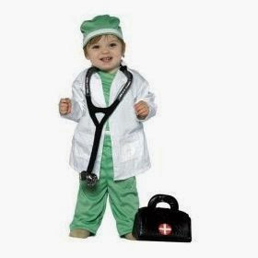
- Make up silly songs: “This is how the nurse weighs you..."
- If you have a scale and a tape measure, you can weigh and measure your child, and they can weigh and measure dolls or stuffed animals
- Encourage your child to play doctor with dolls or stuffed animals

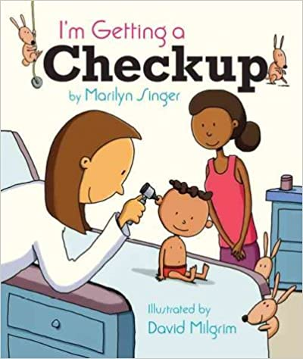
Your library might have some fun books:
- I’m Getting a Checkup by Marilyn Singer
- ABC Doctor by Liz Murphy
- Doctor Ted by Andrea Beaty and Pascal Lemaitre
- My Doctor and Me ABC by Stephanie Cox
- Doctor Maisy by Lucy Cousins

This appointment may take over an hour, so try to find childcare for your other children.
A parent or guardian must go with the child.

