How Can You Help?
• • •

Here are some examples of ways you can provide In Kind for our program:
- Volunteering in the classroom, which may include:
  - Sharing a meal with your child at school
  - Playing outside with children during our outside time
  - Sharing a hobby or talent with the class (ex: singing, woodworking)
  - Reading stories to children
  - Bringing in “treasures” to share with children (ex: artwork, baseball card collections)
  - Cleaning/fixing/gardening/etc. to keep the center looking great
- Completing extension activities provided by your EHS home visitor and listed on the home visiting lesson plan
- Doing at-home activities to further your child’s development:
  - Monthly or weekly At-Home Activity Calendars
  - Activities that are tied to the Creative Curriculum or Parents as Teachers curriculum to help with your child’s school readiness
- Helping with arrangements and participating in field trips, parent meetings, and family engagement activities
- Attending parent trainings and socializations
- Making/preparing materials for the classroom, socialization or your upcoming home visit (ex: cutting out materials for an activity, making play-dough, collecting materials necessary for the home visit activity)
- Travel time, mileage and participation in an Open House, IFSP, IEP, IAP, Emergency Care Plan, and Transition Meeting.
- Mileage to Parent Teacher Conference.
- Travel time and mileage for program-required medical/dental appointments, including WIC, Health Dept., and Dental Clinics North
- Time completing an e-DECA outside of a home visit
- Donating materials to be used in the classroom or socialization space.
- Serving on Policy Council
- Please ask your child’s teacher or home visitor for additional options
Other Ways We Get In-Kind
- Community “celebrities” visiting the classroom (ex: librarian, elementary school principal, firefighter)
- Donated materials from local businesses of food or supplies for classroom or parent activities
- Any volunteer time in the classroom (ex: college students, foster grandparents)
What is In Kind?
NMCAA Head Start

Definition of In Kind

In order to fund NMCAA Child Development programs with the exception of GSRP, we must collect a 25% match of each federal dollar received for our total funding. This funding source is called In Kind and can include donations of time, money, materials, and services. We need help from parents and the local community to continue to operate our Head Start program! Parent involvement in their child’s education is key to their future success and In Kind is a great way to be involved.

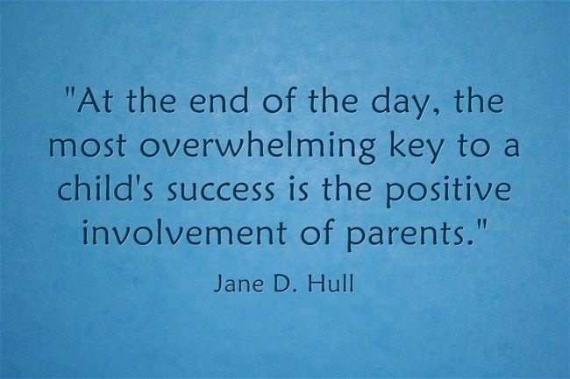
5/23 References: HS 1303.4
HS-EHS Team/ADMIN/Procedure Manual/In-Kind/What is In-Kind?

