How Can You Help?
• • •

Here are some examples of ways you can provide In Kind for our program:
- Volunteering in the classroom, which may include:
  - Sharing a meal with your child at school
  - Playing outside with children during our outside time
  - Sharing a hobby or talent with the class (ex: singing, woodworking)
  - Reading stories to children
  - Bringing in “treasures” to share with children (ex: artwork, baseball card collections)
  - Cleaning/fixing/gardening/etc. to keep the center looking great
- Doing at-home activities to further your child’s development:
  - Monthly At-Home Activity Calendars
  - Activities that are tied to the Creative Curriculum to help with your child’s school readiness
- Helping with arrangements and participating in field trips, parent meetings, and family engagement activities
- Attending parent trainings
- Making/preparing materials for the classroom (ex: cutting out materials for an activity, making play-dough
- Travel time and participation in an Open House, IEP, IAP, Emergency Care Plans, Transition Meetings, and Parent Teacher Conferences
- Travel/appointment time and mileage for program-required medical/dental appointments
- Travel/mileage only for WIC, Health Dept., and Dental Clinics North
- Time completing an e-DECA
- Donating materials to be used in the classroom.
- Serving on Policy Council
- Please ask your child’s teacher for additional options
Other Ways We Get In-Kind
- Community “celebrities” visiting the classroom (ex: librarian, elementary school principal, firefighter)
- Donated materials from local businesses of food or supplies for classroom or parent activities
- Any volunteer time in the classroom (ex: college students, foster grandparents)

Definition of In Kind
What is In Kind?
NMCAA Head Start

In order to fund your child’s Head Start preschool program, we must receive 25% of our funding from local donations of time, money, materials, and services. This funding source is called In Kind. This means we need help from parents and the local community to continue to operate our Head Start program. Parent involvement in their child’s education is key to their future success and In Kind is a great way to be involved.

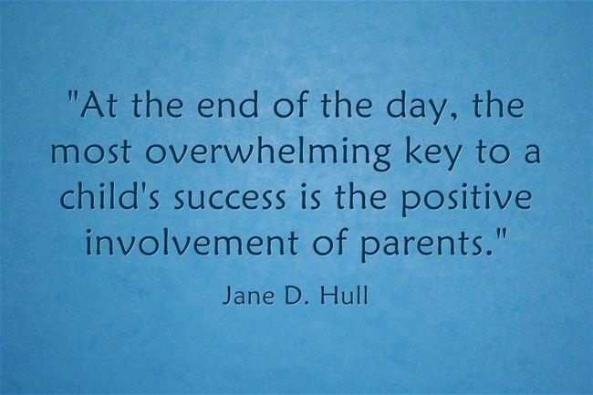

8/20 P:Head Start/Admin/Procedure Manual/Inkind/What is In-Kind?

