Step 1: Signing into the Attendance App
Once you have downloaded the app, you will sign into it using the following:
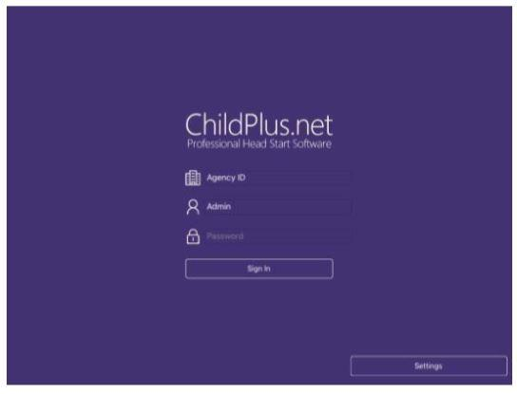

- AgencyID: NWMichigan
- UserName: The first initial of your first name followed by your last name, all in lowercase. Example: jsmith
- Password: Provided by your coordinator

Step 2: Selecting a Classroom
You can select what classroom you want to work with by clicking Please Select a Class. Once you select a class, you will be in the Attendance mode by default. Two other modes are available too.
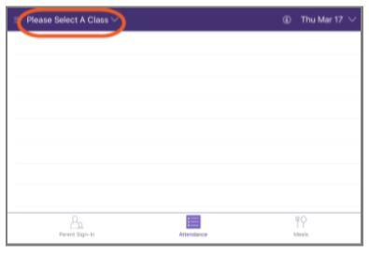

- Parent Sign in: You may choose to use the Parent Sign in mode for parents to sign in. This mode does not allow you to add notes or reasons. See Steps 5 and 6 below for instructions on adding notes and reasons for absences to the Attendance mode.
- Meals: You will not use the Meals mode.
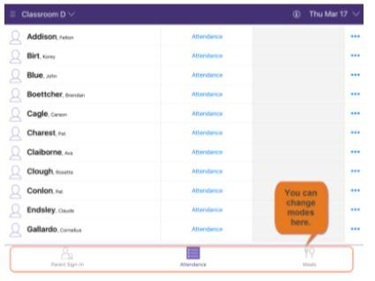

- You may need to scroll down to see all the children in your class.

Step 3: Check the date
By default, the Attendance App will always be set to the current date.
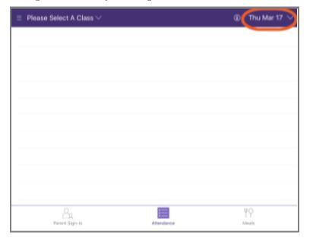

- If you need to work on a date that was previously unopened contact your coordinator for assistance.
Step 4: Recording Daily Attendance
Click the word Attendance to the right of the child’s name. You can then choose which attendance status you would like to assign to the child. Every day, Monday through Friday, needs to have an attendance status.
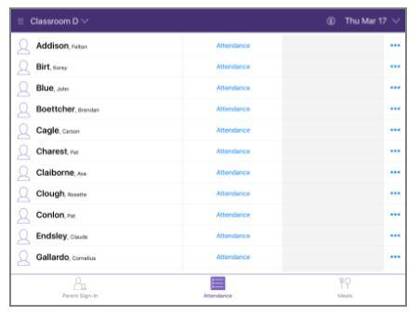

- Enter "Absent" if a child is absent for one of their regularly scheduled days.
- Enter "Present" if a child is present on any day.
- Enter "Not Scheduled":
  - for days that are not included in the child’s consistent schedule.
  - a child does not attend on a snow day and your classroom remains open.
- Enter "No Class" if:
  - your site is closed for a training day, snow day, or holiday.
  - your classroom does not offer care on Friday
Step 5: Reason for Absence

- If you select Absent within the Attendance Status, an option to enter Absence Reason appears in the next column.
- To record the reason for absence, click Absence Reason and select the appropriate option for absence.
Step 6: Adding Notes for Attendance
Once you have completed selecting an absence reason, click the icon in the far-right column and a choice to select Edit Attendance and Notes appears.
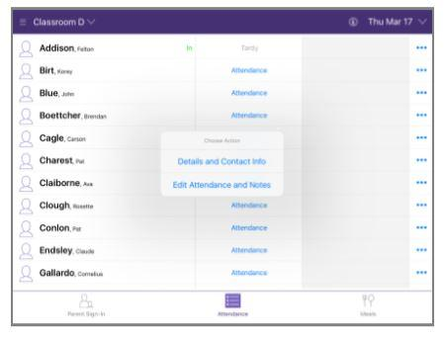

- In the notes space, please indicate the following information each day:
  - specific reason for absence (i.e. strep throat)
  - who contacted who regarding the absence (i.e. mom called the center or the teacher contacted dad through an app)

Unexplained Absences
To ensure child well-being and family safety the following steps are to be implemented for unexplained absences:
- When a child is unexpectedly absent and a parent or guardian has not contacted the program within one hour of the expected time of arrival, the program must attempt to contact the parent by the end of the day. Document the reason for absence and who made the contact in the ChildPlus Attendance App.
- If you are unable to make contact with the family that day, choose "Unexpected Absence" from the "Absence Reason" list.
- Your Coordinator is required to complete a home visit to check for child and family safety if a child has multiple unexplained absences (such as two consecutive unexplained absences). Notify your Coordinator within 24 hours if a student has two unexplained absences on consecutive days, and you are unable to make contact with the family.
Installing FREE apps
- Press GET, then INSTALL
- Enter password (should P@$$word2017 for new ipads)
3. Choose Review
4. Agree to Terms and Conditions, choose Next
- Select Title, choose Next
- Enter the agency main office info:
3963 Three Mile Rd
Traverse City, MI 49686
(800)632-7334
- Select Continue
- Press GET, then INSTALL
- Enter password
- Choose Always Require

