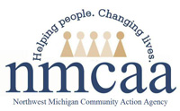
Northwest Michigan Community Action Agency Mission Statement
Helping people by linking services, resources and opportunities.

Head Start Vision Statement
NMCAA leads in strengthening our communities by empowering people to overcome barriers, build connections and improve their quality of life.

NMCAA Program Philosophy
We believe that children need strong families in order to develop into mature adults who are productive members of society. Our goal is to nurture families. We will seek whatever support is available and advocate for what is needed to enable the children in each family to be successful in school.

National Head Start Mission Statement
Head Start is a national program that promotes school readiness by enhancing the social and cognitive development of children through the provision of educational, health, nutritional, social and other services to enrolled children and families.
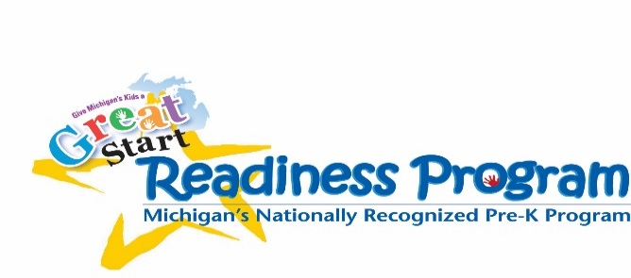
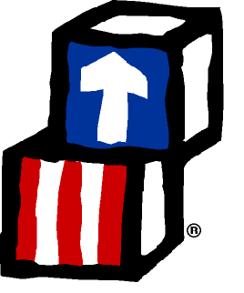

6/18 Original: to be posted P:\Head Start Files\APOT\2018-2019 APOT Documents\Vision-Philosophy-Mission

