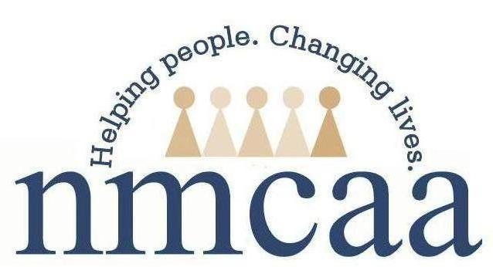
Confidentiality Policy

I, __________________________________________, as an employee/partner of Northwest Michigan Community Action Agency, understand that in the course of my work, I may have access to confidential information. I also have the responsibility to safeguard such information. Any confidential information, whether oral, written, or electronic, should be maintained in a manner that ensures confidentiality. Agency employees and partners shall exercise discretion and tact in all client related matters.

Clients often reveal personal and confidential information in order for the program and staff to serve them. I may learn certain information that is of a personal and confidential nature about individuals who are served by the NMCAA programs. This may include information about families, personal finances, employment, living arrangements, medical conditions and treatments, sexual practices and/or experiences, relations with family and/or friends, other-agency involvement, etc. Clients must rest assured that the information they have provided to staff will be held in the strictest of confidence.

Child files and other related family records are kept confidential. Staff are responsible to keep all paper files in a locked cabinet at the center and electronic files on a secure computer.

I agree not to disclose any information of a personal and confidential nature to ANY person who is not affiliated with NMCAA and authorized to have such information. Only with specific consent of the individual to whom the information pertains will that information be released.

A breach in confidentiality and failure to exercise appropriate care and safeguards in handling client information include but are not limited to:

- Discussing children/families either inside or outside the program with anyone who has “no need to know.”
- Disclosing names, and/or talking about families in ways that will make their identity known to anyone outside the site. The fact that a child is enrolled in the program is confidential information.
- Leaving documents containing confidential information out in an open area.
- Failing to shred records with identifying information

I understand that all such information, including the identity of those individuals, must be completely confidential, even after I am no longer working at or contracting with NMCAA. Any document containing the above confidential information must be stored for the required length of time and then destroyed to avoid the disclosing of confidential information.

I have read NMCAA’s policy on confidentiality. I agree to abide by the requirements of the policy and inform my supervisor immediately if I believe any violation (unintentional or otherwise) of the policy has occurred.

I will also refer to the agency’s policies on social media and email encryption if I have any questions about maintaining sensitive/confidential information, and I may contact my supervisor for any clarification.

I further understand that failure to comply with these terms of confidentiality is grounds for termination of my employment or contract with NMCAA, and may also subject me to possible legal action under the laws of the State of Michigan, and other jurisdictions.

________________________ _________________________
Staff/Provider Signature Supervisor Signature

________________________ _________________________
Date Date

References: HS 1303.24 (a); FERPA 20 U.S.C. 1232g and 34 CFR Part 99 (a-e); IDEA PART B 20 U.S.C. 1400 and 34 CFR Part 300; IDEA PART C 20 U.S.C. 1400 and 34 CFR Part 303
7/19 P:\Head Start Files\Admin\Procedure Manual\Licensing\Confidentiality Policy

